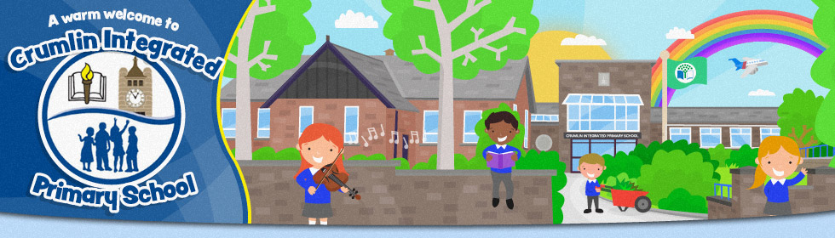
YEAR 1 – SPETEMBER 2021

To confirm your place – please click the following link:
https://forms.gle/7D5PounzxNVuTQvs7

